**Problem.**

We have found that the filter used to overlay overimposed images (FaceOverlayFilter) seems to move the reference square when detecting a face when we are using a HD (High Definition) device.

Devices used.

|  |  |
| --- | --- |
| Model | iPad Air 1 |
| OS version | 9.3.1 |
| Resolutión | 2048x1536 (retina screen) |
| UIView renderer | w:440 – h:587 |

|  |  |
| --- | --- |
| Model | iPad Mini 1 |
| OS version | 9.3.3 |
| Resolutión | 1024x768 (no retina screen) |
| UIView renderer | w:440 – h:587 |

**Documentation.**

In the library docs ([http://kurento-ios.readthedocs.io/en/latest/ dev_guide.html](http://kurento-ios.readthedocs.io/en/latest/%20dev_guide.html)) the following default values are to be used:

/*

Default media constraints:

Audio codec: Opus audio codec (higher quality)

Audio bandiwidth limit: none

Video codec: Software (VP8)

Video renderer: OpenGLES 2.0

Video bandwidth limit: none

Video format: 640 x 480 @ 30fps

*/

The “video format” is set to the corresponding values (values as expressed in the UIView renderer):

self.mediaConfig = NBMMediaConfiguration.defaultConfiguration()

self.mediaConfig!.cameraPosition = NBMCameraPosition.Front

self.mediaConfig!.rendererType = .OpenGLES

self.mediaConfig!.receiverVideoFormat.dimensions.height = Int32(self.video1View?bounds.height)

self.mediaConfig!.receiverVideoFormat.dimensions.width = Int32(self.video1View?bounds.width)

But this does not seem to affect the result.

**Simple Mode.**

Result when using iPad Air 1 (HD):

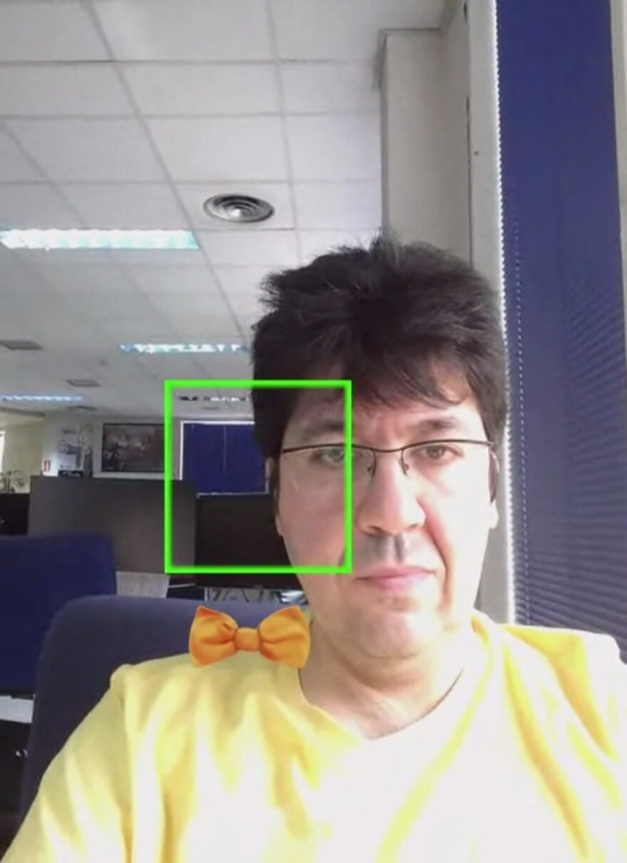

Result when using iPad Mini 1 (SD) (single definition):

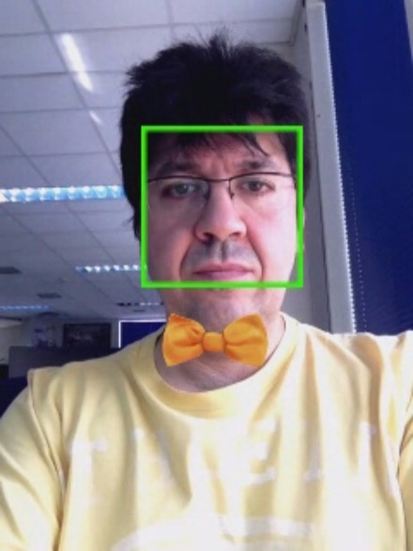

**Conference Mode.**

Result when using iPad Air 1 (HD):

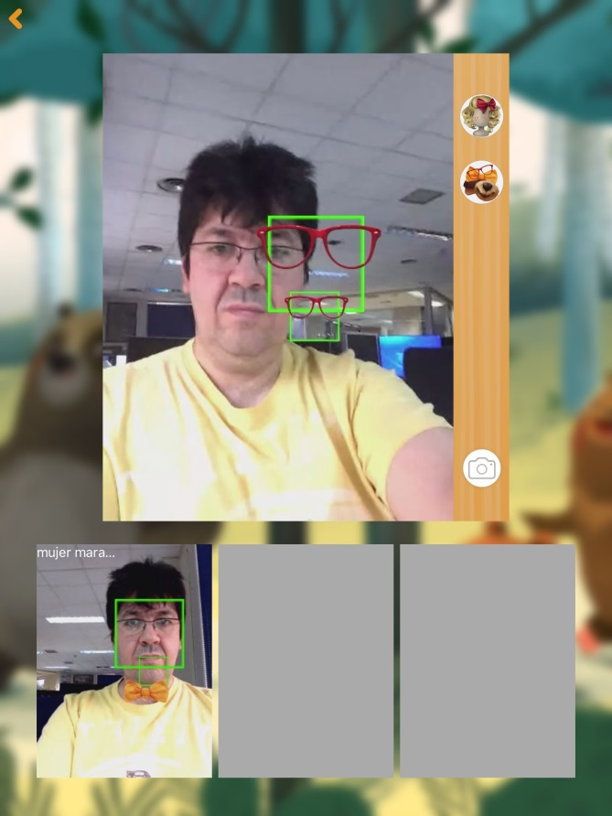

Result when using iPad Mini 1 (SD):

